IFS-Association-Suisse

Selflead Education and Parenting

La Rouvraie, Bevaix (Switzerland) — 18-21 March 2027
IFS offers us keys to support parents and professionals working with children and adolescents, and to rethink parenting and education with them through the many qualities of the Self.

At a time when educational and family challenges are intensifying, and when parents, teachers, educators, and therapists are seeking answers to support young generations in a rapidly changing world, the IFS approach offers a valuable framework. This model helps us understand our own internal mechanisms so we can better support parents and professionals working with children and adolescents, responding to a growing need for meaning, connection, and compassion in education and caregiving.
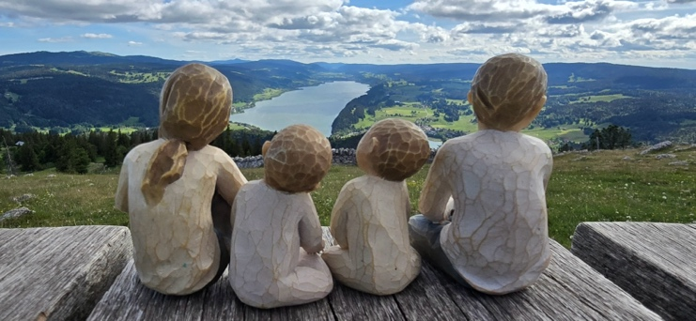
During this seminar, you will explore your own system to identify how your burdened parts may interfere with your role as a therapist working with children, adolescents, parents, educators, teachers, or any other professional working with children and adolescents. You will also discover practical methods and keys for interacting positively with children, helping them express their natural qualities and thrive. In light of these experiences and educational elements, you will learn how to help your clients adopt a Self-led stance as a parent and/or caregiver.
Learning Objectives
By the end of this training, participants will have tools to improve their work with parents and with professionals in the medical, psychological, social, and educational fields who support the development, education, care, and protection of children and adolescents.
Participants will be able to recognize their own burdened parts activated in caregiving situations and to help their clients explore their own parts when they themselves are in a caregiving or educational role.
They will be able to recognize when their clients are using strategies that may place additional constraints on children and adolescents rather than helping them flourish through their natural qualities.
As a result, among other things, they will be able to help their clients:
- interact with children and adolescents in a positive and encouraging way
- promote children's natural abilities and learning styles
- adopt a Self-led stance in service of a deep and authentic relationship
For therapists who work with, or wish to work with, children or adolescents, it is important to note that this training is intended to enrich and support their stance as a therapist, rather than to provide the essential foundations needed to practice therapeutic work specifically aimed at this population.
The Trainer

Seth Kopald holds a doctorate in organizational management with a specialization in leadership, as well as a master's degree in education. His research focused on creating safe environments in which everyone can express themselves and feel heard. Seth is also a certified Montessori teacher, specializing in working with children aged two and a half to six years old. He taught preschool-aged children, then taught child development and early childhood education at a community college. He then spent the following 15 years consulting for nonprofit childcare organizations to help improve their educational practices. Seth is a devoted parent, and he has been teaching parenting classes and supporting parents since 1996.
Seth has been an IFS practitioner since 2012 and an IFS training assistant for Levels 1, 2, and 3. He has also been part of Dick Schwartz's team for numerous retreats and leads his own retreats and workshops.
He works with individuals and couples to help them lead more heart-centred lives through better communication and authentic relationships. He is known for his ability to create spaces where people's parts feel safe and understood.
He is the author of the book Self-Led, in which he guides readers in building authentic relationships with themselves and with others.
His areas of expertise include spirituality, deep listening, communication coaching, leadership, the art of working with parts, and, of course, Self-led parenting.
Why did we choose to invite Seth to lead this seminar?
During our seminar on IFS in the Service of Reconnection, our trainer Jory Agate warmly recommended that we invite Seth Kopald, not only for his valuable expertise in Self-led parenting and education, but also, and above all, for his human qualities and his ability to convey this topic with great depth.

Practical Information
Dates: 18-21 March 2027
Schedule: Day 1: 9:30 AM – 6:00 PM (check-in from 9:00 AM)
Days 2 and 3: 9:00 AM – 6:00 PM
Day 4: 9:00 AM – 4:00 PM

Duration: 26 hours

Venue: La Rouvraie, Bellevue A, 2022 Bevaix (Switzerland)
www.larouvraie.ch

Fee: CHF 920 (or €995)
price per training day: CHF 200 (€217) for the training + CHF 30 (€32) for snacks and lunch
A CHF 20 discount is granted to IFS-Association-Suisse members in good standing with their membership dues.

Prerequisites: IFS Level 1 training, or by application

Target audience: IFS therapists working with individuals (adults, adolescents, children) and/or couples

Language: Training translated from English into French
Practice and sharing groups in French or English
Accommodation: You may stay on-site or in the surrounding area, depending on your preference.
So that you can best organize the portion of your stay that is your responsibility, we will send you further information once your registration has been confirmed.

Organized by: IFS-Association-Suisse

Registration Form
Seminar “Parenting and Education Guided by the Self”
18-21 March 2027 in Bevaix (Switzerland)
to be sent to secretariat@ifs-association-suisse.org
Your contact details
Last name: ______________________ First name: ______________________
Street and No.: ________________________________________________
Postal code: ___________ City: ________________________ Country: ________________
Phone: ______________________ Email address: ______________________
Occupation: ________________________________________________
I completed my Level 1 training in (year) __________ in (location) __________
with (name(s) of the trainer(s)): ________________________________________
Other IFS trainings:

Would you like an invoice?
O Yes O No
If yes, please provide the following information:
Company name: ______________________ VAT No.: ______________________
Last name: ______________________ First name: ______________________
Street and No.: ________________________________________________
Postal code: ___________ City: ________________________ Country: ________________
Organization
O I agree that my contact details may be shared with other seminar participants, among other things to help organize carpooling.
For lunch, I choose the following option (for the entire stay):
O standard meals OR O vegetarian meals
And in case of intolerance or allergy (the cook will accommodate as far as possible):
O gluten-free diet O lactose-free diet O other (please specify): ______________________

Cancellation policy prior to the start of the training
In the event of cancellation by the participant, the following fees are due to IFS-Association-Suisse:
- 0% if cancellation occurs within ten days of signing your registration;
- 50% of the total training fee if cancellation occurs between the end of the withdrawal period and 30 calendar days before the start date of the training;
- 100% of the total training fee if cancellation occurs within the 30 calendar days preceding the start date of the training;
- If you cancel more than ten days after signing your registration, you may arrange for a substitute who meets the prerequisites to take your place. However, a fee of CHF 150 will remain payable to the association for administrative costs.
In the event of cancellation by IFS-Association-Suisse, the association undertakes to fully reimburse the participant for all training fees paid.
Date Signature

